AJM Digital Solutions: Company Overview
I. Executive Summary
AJM Digital Solutions is a forward-thinking technology company specializing in delivering custom, cutting-edge digital transformation services. We partner with businesses—from startups to established enterprises—to enhance efficiency, optimize customer engagement, and drive measurable growth through the intelligent application of modern technology stacks. Our core mission is to bridge the gap between business goals and technical execution, ensuring our clients remain competitive in an increasingly digital world.
II. Core Mission & Vision
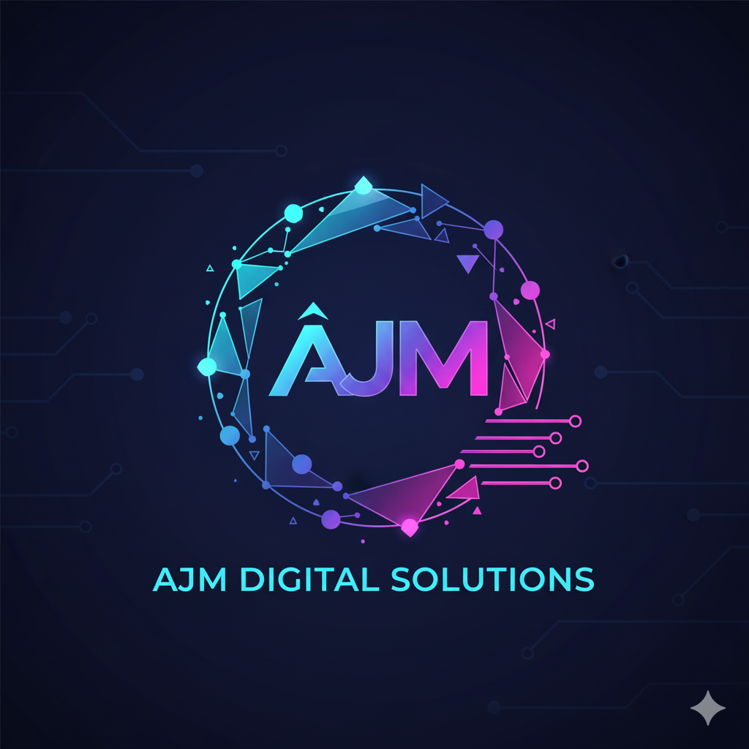
- Mission: To empower businesses with scalable, robust, and innovative digital solutions that automate processes, improve decision-making, and create superior value for their end-users.
- Vision: To be the leading global partner for digital transformation, recognized for technical excellence, creative problem-solving, and unwavering client success.
III. Key Service Offerings
AJM Digital Solutions offers a comprehensive suite of services organized into three main pillars:
1. Software Development & Architecture
- Custom Application Development: Building bespoke web and mobile applications tailored to unique business needs (e.g., SaaS platforms, internal tools).
- Cloud Architecture & Migration: Designing, deploying, and managing scalable infrastructure on leading cloud platforms (AWS, Azure, Google Cloud).
- API Development & Integration: Creating robust interfaces to connect disparate systems and enable seamless data flow.
2. Digital Transformation & Strategy
- Consulting: Assessing current technology landscapes and developing clear roadmaps for digital maturity.
- Legacy System Modernization: Migrating outdated systems to modern, maintainable technology stacks.
- Process Automation: Implementing tools and workflows (RPA, AI) to minimize manual work and increase operational speed.
3. Data & Analytics
- Business Intelligence (BI): Designing and implementing data warehousing and dashboard solutions to provide actionable insights.
- Machine Learning (ML) / Artificial Intelligence (AI): Developing predictive models and intelligent features (e.g., recommendation engines, anomaly detection) to enhance products and services.
IV. Differentiating Factors
- Technology Agnostic Approach: We prioritize the right tool for the job, rather than forcing a specific technology, ensuring the most efficient and future-proof solution.
- Focus on Business Value: Every solution we develop is tied directly back to a measurable business objective, ensuring a strong return on investment (ROI).
- Agile Methodology: We utilize flexible, iterative development processes (Scrum/Kanban) to ensure transparency, rapid adaptation, and continuous client feedback.
- Security by Design: Security protocols are integrated from the initial planning phase, ensuring robust and compliant systems.
V. Target Clientele
AJM Digital Solutions is ideally suited to partner with:
- Mid-Market Companies: Businesses experiencing rapid growth that require scalable technology infrastructure.
- Enterprises: Large organizations needing to modernize legacy systems or execute complex, multi-faceted digital transformation projects.
- Technology Startups: Providing specialized expertise to quickly build out core product features and scale infrastructure efficiently.

